**РОЛИКИ КОНВЕЙЕРНЫЕ**

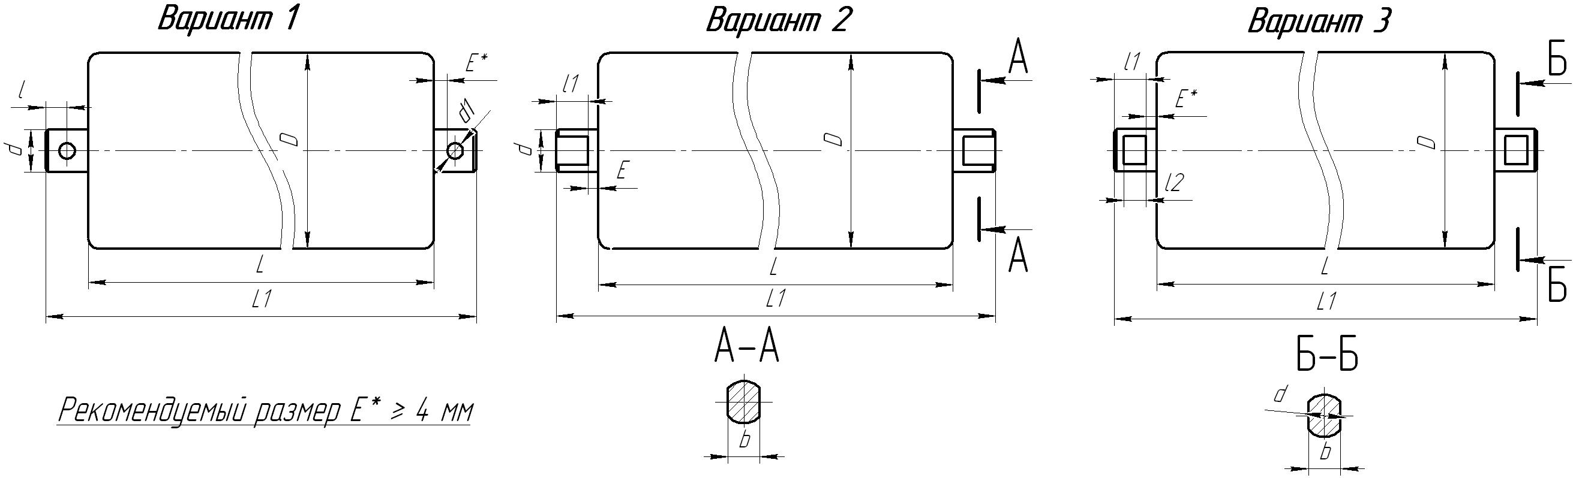

|  |  |  |  |  |  |  |  |  |  |  |  |  |
| --- | --- | --- | --- | --- | --- | --- | --- | --- | --- | --- | --- | --- |
| ***Номер варианта*** | ***D*** | ***L*** | ***L1*** | ***d*** | ***d1*** | ***l*** | ***l1*** | ***l2*** | ***b*** | ***E*** | ***Подшипник*** | ***Количество*** |
| 2 | 102 | 250 | 280 | 20 |  |  | 12 |  | 14 |  | 204 | 200 |
| 2 | 102 | 750 | 780 | 20 |  |  | 12 |  | 14 |  | 204 | 40 |
|  |  |  |  |  |  |  |  |  |  |  |  |  |
|  |  |  |  |  |  |  |  |  |  |  |  |  |
|  |  |  |  |  |  |  |  |  |  |  |  |  |
|  |  |  |  |  |  |  |  |  |  |  |  |  |
|  |  |  |  |  |  |  |  |  |  |  |  |  |