Product: Frozen Chicken Feet, B Grade
Product description |  |  |  |  |  | Processing Chart
B Grade: Frozen Chicken Feet  Weight: min 28 (g) - max 63 (g); Average weight: |  |  |  |  |  | Whole Chicken  Automatic cutting line  Chicken Feet line  Quality checking  Cleaning, Washing  Quality checking  Removing Ammonia burn & quality checking  quality checking  water settling  Quality Checking  Packing  Freezing
Allowed  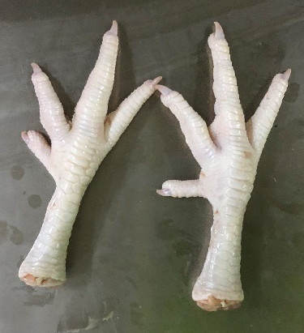 |  | Allowed   |  |  | Allowed  
Not Allowed   |  |  | Not Allowed  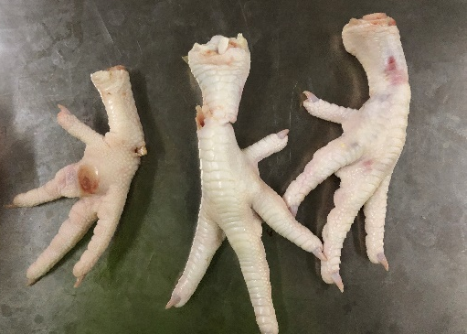
Packaging pictures
Allowed |  |  |  | 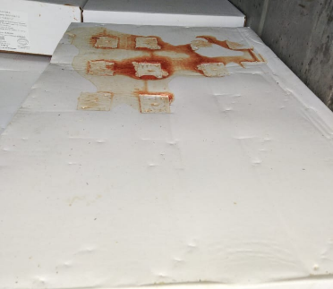  Not Allowed
Possible damage |  |  |  | Product details
M/C | % |  |  | - Net weight 1 cartoon box (before freezing) |  | Fix 15 kg
Bone breakage | % |  |  | - Shelf life frozen |  | 12 month
Others | Clean  White skin, no yellow skin, no feathers  No odor, no scars  No black spots or chemical burns  No excessive blood, no blood congestion |  |  | - Temperature storage |  | No more than -18°C

