Ref. No. 158
Date: July 07.17
To:
Attn
Address:
LETTER OF INTENT

We, EASTERN EUROPE AIR, represented by Mr. ARŪNAS CIBULSKAS (CEO), with the full responsibility as the Buyer hereby express our intention and capability to enter into a Sales Contract with your company on the following terms:

Goods: EN590 10ppm
Origin:
Quality: Standard export quality (to be provided the Specs of the product)
Quantity: 2,500,000 MT per year (trial batch 100,000 MT + 200,000 MT per month x12 months)
Period: 13 months (with possible extension up to 37 months)
Delivery: TTO (tank-to-tank), (tank-to-tanker) Mersin port, or Rotterdam port.
Price: For trial batch & Contract discounts: Gross 25 %, Net 20 % from Platt’s FOB Med Italy
or FOB Med Rotterdam.
Commission: Buyer pays 5 % from Platt’s FOB Med Italy or FOB Med Rotterdam under NCNDA/IMFPA
Payment: For Trial batch and Commission by SWIFT MT103
For Contract by SWIFT MT103 for each delivery
Inspection: SGS or similar

PROCEDURES: sale from tank to ship

- The Buyer issues the LOI.
- The Seller responds with the SCO.
- The Buyer issues an ICPO, with the Buyer's bank details, Company Profile, a copy of the Buyer's international Passport.
- The Seller issues to the Buyer an FCO and a draft Memorandum between the Seller and the Buyer, on the transaction for the purchase of petroleum products.
- The Buyer signs the Memorandum and returns it to the Seller.
- After the successful completion of the Buyer's solvency check, the Seller sends a Commercial Invoice (CI) for the available quantity of the trial batch of goods in the Seller's tank.
- The Seller sends the partial POP documents to the buyer, as indicated below:
- Obligation and guarantee of delivery;
- Statement of product availability;
- Certificate of Origin;
- Authorization to Verify (ATV);
- Unconditional DTA;
- SGS report on the inspection of the goods in the seller's tanks;
- Tank Storage Receipt (TSR);
- Authorization to Sell and Collect (ATSC);
- Pre-injection Report.
- The Buyer conducts an immersion test (the Dip Test) into the Seller's tank.
- The Seller will give a time period of two working days (counted after the day of the Dip Test) to the Buyer to perform the payment of the goods.
- The Seller provides to the Buyer with free storage of the goods for 48 hours in their tank/s for the organization of pumping of the goods.
- The Seller and the Buyer sign an Agreement on the temporary storage of the goods in the Seller's tanks for the period of time necessary for the Buyer, until the Buyer will take over the product (either in a storage tank or a vessel), and the Buyer pays for the temporary storage of the goods in the Seller's tank/s, if the Buyers exceeds the 48 hours as mention in the point 10 above.
- The Seller transfers to the Buyer the title ownership of the goods, as well as the lessor contract of this tank on the Buyer’s name (if it is the case), and will issue the permission to the Buyer to pump the goods into the buyer's vessel or into the buyer's tank (ATI)
- The Buyer will make the payment of the goods to the Seller.
- The Seller confirms to the Buyer the receipt of payment for the goods and transfers to the Buyer all export documents for the goods.
- The Seller, in agreement with the Buyer, sends draft SPA Contract to the Buyer.
- The subsequent delivery of the goods begins in accordance with the terms of the Contract.
PROCEDURES: sale from tank to tank
- The Buyer conducts an immersion test (the Dip Test) into the Seller's tank.
- The Seller will give a time period of two working days (counted after the day of the Dip Test) to the Buyer to perform the payment of the goods.
- The Seller provides to the Buyer with free storage of the goods for 48 hours in their tank/s for the organization of pumping of the goods.
- The Seller and the Buyer sign an Agreement on the temporary storage of the goods in the Seller's tanks for the period of time necessary for the Buyer, until the Buyer will take over the product (either in a storage tank or a vessel), and the Buyer pays for the temporary storage of the goods in the Seller's tank/s, if the Buyers exceeds the 48 hours as mention in the point 10 above.
- The Seller and the Buyer sign an Agreement on the temporary storage of the goods in the Seller's tanks for the
- The Seller transfers to the Buyer the title ownership of the goods, as well as the lessor contract of this tank on the Buyer’s name (if it is the case), and will issue the permission to the Buyer to pump the goods into the buyer's vessel or into the buyer's tank (ATI)
- The Buyer will make the payment of the goods to the Seller.
- The Seller confirms to the Buyer the receipt of payment for the goods and transfers to the Buyer all export documents for the goods.
- The Seller, in agreement with the Buyer, sends draft SPA Contract to the Buyer.
- The subsequent delivery of the goods begins in accordance with the terms of the Contract.

Information about the Buyer:

COMPANY NAME | EASTERN EUROPE AIR
REGISTRATION NUMBER COMPANY | 203931856
COMPANY ADDRESS | 1, BRUSSELS BOULEVARD, SOFIA, BULGARIA
REPRESENTED BY | ARŪNAS CIBULSKAS
POSITIONIN COMPANY | DIRECTOR
PASSPORT/ID NUMBER | 25423826
PASSPORT/ID DATE OF ISSUE | 22.12.2020
PASSPORT/ID EXPIRY DATE | 22.12.2030
NATIONALITY | LITHUANIA
E-mail | vidrava@gmail.com
Information about the Buyer’s Bank:
BANK NAME: | COMMERRZBANK AG
BANK ADDRESS: | Firmenkunden Lützowplatz 410785 Berlin
ACCOUNT NAME: | EASTERN EUROPE AIR
IBAN ACCOUNT № | DE64 1004 0000 0301 4735 00
SWIFT/ BIC CODE: | COBADEFFXXX

This document is the legal basis for the transfer by the Seller of the accepted names, values and volumes to the draft of the Contract being prepared.


(signature, seal)

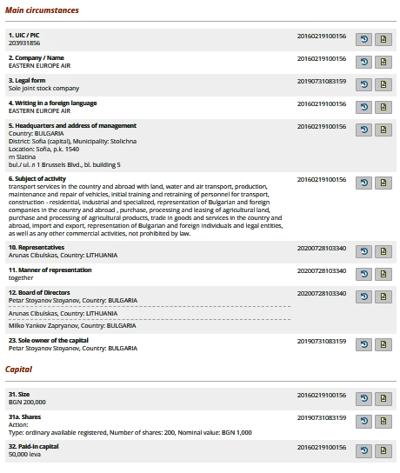
CERTIFICATE OF INCORPORATION


(signature, seal)

