Объект: | «»
Контракт №:

ОПРОСНЫЙ ЛИСТ

Chemical Water Treatment

№ | Параметры | Значение | Примечание
 | General Data
 | Object name
 | Equipment name | Water Treatment Plant
 | Purpose of the equipment | The chemical water treatment plant is designed to purify raw water to the quality required for feed water of steam and hot-water boilers..
 | Type of construction | New construction
 | Technical specification set up
 | General specifications | The chemical water treatment plant shall include the necessary equipment that will ensure purification of raw water to the quality of feed water for steam and hot water boilers.  Subsequent removal of dissolved oxygen from chemically treated water will take place in a thermal deaerator (not included in the scope of supply of chemical water treatment).  The chemical water treatment plant must operate in automatic mode.
 | Source of feed water for chemical water treatment needs | Household. Drinking water supply and ground water | Quality indicators of initial (raw) water see Annex 1. Annex 1 and 2
 | Working capacity of chemical water treatment total, m3/h | 8
 | Estimated raw water capacity of the chemical water treatment plant, m3/h | 8
 | Feed water demand of steam boilers, m3/h | 3,68 further feeding at 1.7m3/h | Показатели качества питательной воды котлов см. Приложение 2, таблица 1
 | Feed water demand of hot water boilers, m3/h | 1,0
 | Pumping station for supplying chemically treated water from chemical water treatment to the deaerator with the following characteristics:  G, m3/h  H= m water column. | 3,68  55
 | Number of water treatment equipment, comp. | Provide a reserve stock of equipment to maintain the stated capacity of the chemical treatment plant | The process flow diagram of the plant is determined by the Equipment Supplier
 | Requirement for auxiliary equipment
 | Main requirements | Technological scheme of the chemical water treatment plant should include filters, water storage tanks, pumping stations, salt dissolvers, dosers, piping with shut-off and control valves, etc., which will ensure continuous operation of chemical water treatment in automatic mode.
 | Reagent facility | Provide for
 | Warehousing and storage facilities | Provide for dry and wet salt storage warehouses | The necessity and size of the warehouses shall be determined by the Equipment Supplier.
 | Architectural and construction requirements
 | Design solutions | The layout of the chemical water treatment plant shall be performed in accordance with the requirements of the current norms KMK 2.04.13-99 Boiler Plants and the rules "Rules of device and safe operation of steam and hot-water boilers".  The CWP equipment will be installed in the boiler house building.  Architectural and construction solutions of the chemical water treatment building (including foundations) are fulfilled by the Customer according to the technical assignment of the Equipment Supplier.  Outside the chemical water treatment building, if necessary, equipment or facilities required for the operation of the plant shall be located near the chemical water treatment building.  Heating, ventilation (air-conditioning) systems in accordance with the current norms and rules: KMK 2.04.13-99, KMK 2.04.05-97, as well as water supply and sewerage systems in accordance with the requirements of KMK2.04.01-98 will be provided in the chemical water treatment premises. These requirements are fulfilled by the Customer | Компоновку см. приложение 3
 | Автоматизация установки водоподготовки
 | Scope of automation | Provide an automatic process control system (APCS), which, together with control cabinets, instrumentation sensors, and shut-off and control valves, will ensure automatic operation of all chemical water treatment equipment in accordance with the requirements of current rules and regulations for boiler plants with personnel.
 | Communication with the boiler plant control system | Ethernet или Modbus RTU (RS-485)
 | Requirements for electrical equipment
 | Category of boiler house by reliability of power supply | Second
 | Limitation on the installed electric capacity of the boiler house power consumption, kW | It is possible to limit the installed electric power of the electric motors as much as possible in compliance with the requirements of the technological parameters.  The electric motors of pumping stations must be equipped with frequency converters
 | Power supply system | 220 (380) V; 50 Hz
 | Spare parts requirement
 | Individual units | Provided by the Supplier for the period of warranty operation - not less than 2 years | -
 | Separate parts | Provided by the Supplier for the period of warranty operation - not less than 2 years | -
 | Additional requirements
 | Technical documentation | The Supplier shall provide the Customer with design documentation for approval:  - layout drawings of the chemical water treatment plant in DWG format with specification;  - on the layout drawings indicate the reference of inlet/outlet points of working media, parameters, flow rates of working media and diameters of branch pipes at the connection points;  - technical specification for design of foundations of the supplied equipment with indication of overall dimensions in plan view, location of fixing, anchor bolt sizes, static and dynamic loads, etc.,  - piping diagram of instrumentation devices (P&ID) of the water treatment plant,  - package of documentation for the chemical water treatment control system;  - single-line electrical diagrams,  - power supply loads,  - required quantity of source water and quantity and composition of effluents,  - specification of equipment, products and materials included in the scope of supply of chemical water treatment and auxiliary equipment.  The Supplier is obliged to provide the Customer with information on technical and economic indicators of the chemical water treatment plant (CWTP) operation:  1) Data on the volume and quality of wastewater after the chemical water treatment equipment, as well as the composition and concentrations of pollutants in the wastewater.  2) Summary table of consumables and chemical reagents (if necessary) for a period of 1 year.  3) Calculation of the production cost of chemically treated water ($ per 1 m3) using the proposed WWTP equipment.  All submitted documentation should be in Russian language.
 | Equipment requirements | The supplied equipment must be new, not used and meet the requirements for technical characteristics, efficiency, reliability and comply with the material performance of the operating conditions.  The equipment must have minimal dimensions, be supplied with technological units with the necessary support and fasteners.  The supplied equipment must be accompanied by:  - specification of operational materials and reagents to be used during the operation of the installation, as well as requirements for the frequency of their replacement or cleaning;  - certificates of compliance with the requirements of industrial and fire safety, as well as certificates of conformity and recognition of the type of measuring instruments in the Republic of Uzbekistan;  - necessary technical documentation: factory passports, technical description, manufacturer's instructions for repair, maintenance, operation and installation of equipment, technical, installation and electrical diagrams, assembly drawings with specifications, imported equipment and tools must have the manufacturer's technical documentation translated into Russian and certified in accordance with the established procedure;  - technical and shipping documentation in hard copy;  - the equipment must comply with the requirements of norms and regulations in the field of industrial safety: CMC 2.04.13-99 "Boiler installations",  "Rules for the design and safe operation of steam and hot water boilers" approved by the Gosgortehnadzor of the Republic of Uzbekistan, "Rules for the installation of electrical installations", as well as other regulatory documents in force in the Republic of Uzbekistan. at the time of commissioning of the facility.
 | Scope of delivery | The scope of delivery of the chemical water treatment plant is determined by the supplier based on the quality of the source water and the required quality of feed water of steam and hot water boilers
 | Design boundaries | The boundary of the design of the chemical water treatment plant and pumping stations:  – counter flanges on the supply and discharge pipelines of working media with shut-off and control valves within the binding of the supplied equipment,  - engineering networks and communications  - service platforms, stairs,  - automation and power supply of the supplied equipment.  The equipment supplier develops and submits to the Customer the following design documentation for the installation of chemical water treatment of feed water:  - P&ID scheme,  - equipment layouts,  - pipeline plans and sections,  - assignment for a building (room) for the installation of chemical water treatment,  - assignment for the foundations of equipment,  - specification of equipment products and materials;  - automation section;  - section of electrical solutions.  External supply of engineering networks is provided by the Customer in accordance with the task provided  by the Supplier.
 | The need for installation supervision | require
 | The need for commissioning | require
 | The need for water analysis to remove the necessary components after chemical water treatment equipment (carried out by the Licensor Supplier in the presence of the Customer) | require
 | Training of personnel (provision of information and advisory services) on the operation of equipment | require
 | The need for equipment delivery | require
 | Overall dimensions and weight of the chemical water treatment unit | The blocks of the water treatment plant and equipment must have transport dimensions and weight that will allow them to be transported by rail according to GOST 9238-2013, by water or special road transport on general roads in all weather conditions. Rigging points must be provided on all transport units.
 | Transportation | The equipment, which is assembled into transportable blocks, must withstand the impact of transport shaking at a speed of 50 km/h on asphalt-paved roads, 30 km/h on gravel and cobblestone roads, 15 km/h on dirt roads.
 | warranty | The service life of the equipment is at least 20 years, the warranty for equipment, pipe fittings and instrumentation is 2 years from the date of commissioning, but not more than 36 months from the date of delivery (at the request of the Customer).

ПРИЛОЖЕНИЕ 1
The quality of the source (raw) water
The quality of the source (raw) water corresponds to the drinking water standards approved in the Republic of Uzbekistan (normative indicators are given below:

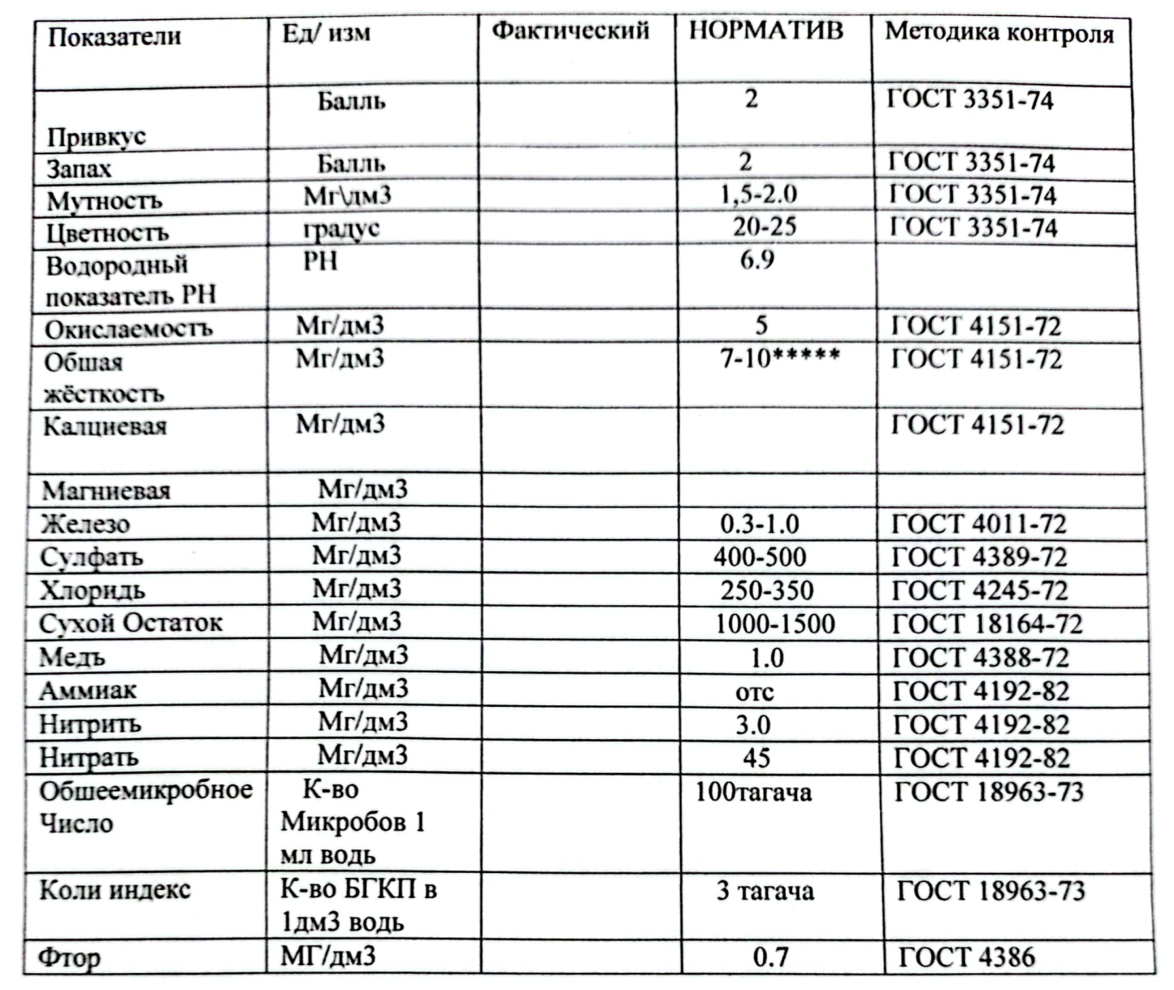

Also in the archive there will be analyses of ground water
ПРИЛОЖЕНИЕ 2
Показатели качества питательной воды для паровых котлов

Таблица 1- Качество химочищенной воды для питания паровых котлов
№п.п. | indication | Unit of measurement | significance
 | pH at 25 °C | - | 9,2
 | Total Stiffness (Ca +Mg) | μg/ kg. | 40
 | Concentration of Na + K | Mg/L | -
 | Iron Concentration (Fe) | Mg/L | Not standardized
 | Copper Concentration (Cu) | Mg/L | Not standardized
 | Silica concentration SiO2 | Mg/L | -
 | Dissolved oxygen (O2) | мкг/кг | 150
 | Concentration of petroleum products | Mg/kg | ≤5
 | Concentration of organic substances (TO C) | Mg/L | -
 | Permanganate index | Mg/L | 5

Таблица 2- Качество химочищенной воды для питания водогрейных котлов
№п.п. | Показатель | Единица измерения | Значение
 | pH при температуре 25 °С | - | 8,3-9,0
 | Карбонатный индекс | (г-экв/м3)2 | 3,0
 | Растворенный кислород | г/м³ | Не более 0,05
 | Свободная углекислота | г/м³ | отсутствует
 | Взвешенные вещества | г/м³ | Не более 5,0
 | Масла и нефтепродукты | г/м³ | Не более 0,3

ПРИЛОЖЕНИЕ 3
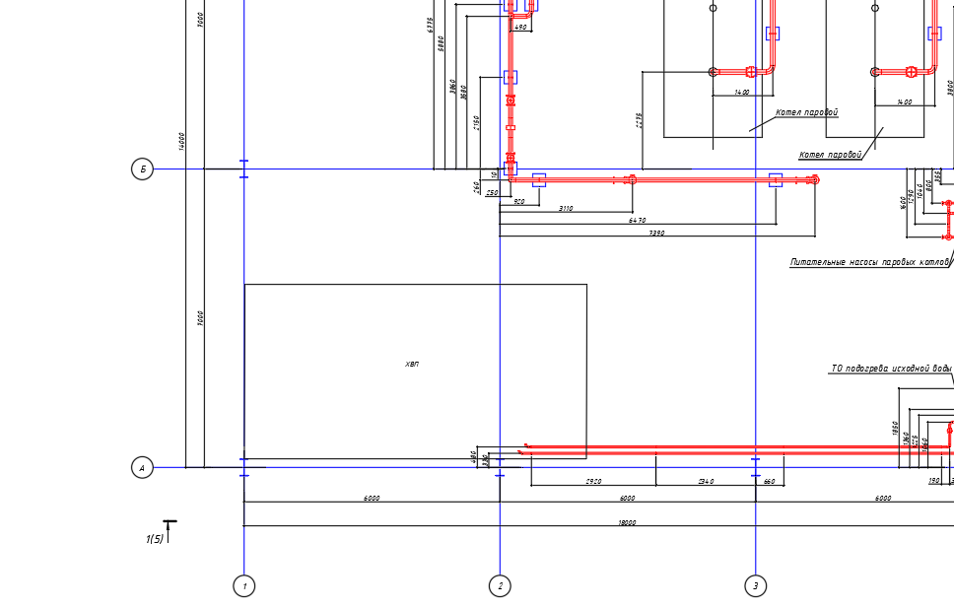

Габариты площадки под оборудование ХВП 8000х3000

A1

